Significant Disproportionality Report User Guide

**February 2024**

This user guide is the reference document for the Significant Disproportionality Report, a Power BI report that can be connected to a state’s instance of the CEDS Data Warehouse used by Generate to determine which LEAs have significant disproportionality and to facilitate conversations regarding reasonable thresholds, minimum n and cell sizes, standards for reasonable progress, and root cause analysis discussions with LEAs.

This technical guide contains report prerequisites, instructions for preparing the CEDS Data Warehouse for the report, instructions for downloading and connecting the report to the CEDS Data Warehouse, best practices for distributing the report, and information about refreshing data within the report.

# Background

This report uses three years of data for the calculation of Significant Disproportionality. The report will allow states to adjust thresholds, N, and Cell Sizes. The report also contains options for reasonable progress allowing it to be measured via a risk ratio or a percentage reduction.

When using this report, be aware that it is not intended to be public facing, as it contains PII and small cell sizes that may allow students to be identified.

# Assistance

If you require assistance with preparing data or the CEDS Data Warehouse, please contact Generate Help: GenerateHelp@aemcorp.com

# Prerequisites

* This report requires states to be users of Generate or a CEDS Data Warehouse.
* Three years of data migrated into Generate for EDPass Files:
  + FS052 – Membership
  + FS002 – Children with Disabilities (School Age)
  + FS006 – Students with Disabilities (IDEA) Suspensions/Expulsions
  + FS143 – Children with Disabilities (IDEA) Total Disciplinary Removals
* The latest version of Power BI Desktop
* Access to the CEDS Data Warehouse
* VPN Access if required

# Preparing CEDS Data Warehouse

The Significant Disproportionality report uses stored views of data in the Reporting Tables. These views are not standard, but can be added to your instance of Generate’s semantic layer easily. This process does not require any server backups.

Generate Significant Disproportionality views were developed to represent the data used for Child Count, Membership, Placement, and Discipline data in C006 and C143 IDEA reports. These files were developed using Generate 11.3 released in early 2024 and they use the same logic for returning the IDEA submission report results. The views contain fact and dimension table ids that are joined with other fact and dimension tables within the data warehouse to return other data elements used within the BI report.

**The Required views are:**

* vwSignificantDisproportionality_Membership
* Description: All students that are enrolled in a school for the report year, are in grades ungraded, 'AE', and PK through 12 and are between the ages 3-21
* Fields Returned:
* Fact.FactK12StudentCountId
* Fact.K12StudentId
* Fact.SchoolYearId
* Fact.LeaId
* LEAs.LeaIdentifierSea
* LEAs.LeaIdentifierNces
* Fact.RaceId
* Fact.IdeaStatusId
* Fact.GradeLevelId
* Fact.AgeId
* 1 AS MembershipStudentCount
* vwSignificantDisproportionality_ChildCount
* Description: All IDEA students that are enrolled in a school for the report year, and are between the ages 3-21
* Fields Returned:
  + Fact.FactK12StudentCountId
  + Fact.PrimaryDisabilityTypeID
  + Fact.K12StudentId
  + Fact.SchoolYearId
  + Fact.LeaId
  + LEAs.LeaIdentifierSea
  + LEAs.LeaIdentifierNces
  + Fact.RaceId
  + Fact.IdeaStatusId
  + Fact.GradeLevelId
  + Fact.AgeId
  + 1 AS ChildCountStudentCount

* vwSignificantDisproportionality_C006
* Description: Aggregated counts of IDEA students that are not parentally placed in private school, and Idea Interim Removal EDFacts Code is not REMDW (removal for drugs, weapons, or serious bodily injury) or REMHO (removed based on a Hearing Officer finding), and are between the ages 3-21
* Fields Returned:
  + K12StudentId
  + PrimaryDisabilityTypeId
  + SchoolYearId
  + LeaId
  + RaceId
  + LeaIdentifierSea
  + LeaIdentifierNces
  + IdeaStatusId
  + GradeLevelId
  + AgeId
  + INSCHOOL_LTOREQ10 (In school removal length less than or equal 10)
  + INSCHOOL_GREATER10 (In school removal length greater than 10)
  + OUTOFSCHOOL_LTOREQ10 (Out of school removal length less than or equal 10)
  + OUTOFSCHOOL_GREATER10 (Out of school removal length greater than 10)
* vwSignificantDisproportionality_C143
* Description: Aggregated counts of IDEA students that are not parentally placed in private school, has a disciplinary action taken is either expulsion with services or expulsion without services, individual duration of disciplinary action is greater or equal to 0.5, and they are between the ages 3-21
* Fields Returned:
  + SchoolYearId
  + LeaId
  + RaceId
  + LeaIdentifierSea
  + LeaIdentifierNces
  + DisciplineCount (Aggregated count)

* vwSignificantDisproportionality_C143_StudentDetails
* Description: All students that are included in the view vwSignificantDisproportionality_C143
* Fields Returned:
  + K12StudentId
  + SchoolYearId
  + LeaId
  + RaceId
  + LeaIdentifierSea
  + LeaIdentifierNces
  + DisciplineCount (Aggregated count by student)
* vwSignificantDisproportionality_Placement
* Description: All IDEA students by Idea Educational Environment
* Fields Returned:
  + K12StudentId
  + SchoolYearId
  + RaceId
  + GradeLevelId
  + LeaIdentifierSea
  + PrimaryDisabilityTypeID
  + IdeaEducationalEnvironmentForSchoolAgeCode
  + IdeaEducationalEnvironmentForSchoolAgeDescription

### Adding the Views

To add the required views save the script **Insert Script Name/link**/instructions for downloading.

Open each view in your SQL Management Studio (or similar) open and execute the view into your copy of the data warehouse. This will add the required views.

If you change the name, field names, or the values returned, you will need to update the BI tool to reflect the changes.

### Note

The logic in these views may need to be changed if the reporting requirements change for how child count, placement, or reports 006 and 143.

# Connecting the report to the source

The .pbix file with a copy of the report is available in the CEDS Collaborative Exchange’s GitHub folder: <https://github.com/CEDS-Collaborative-Exchange/CIID-Reports>.

The downloaded report contains cached test data. This test data was created by CIID for this report's production and is not intended to represent any actual state data. To use the report with your state’s data, **you will need to connect your instance of the report to your CEDS Data Warehouse**.

Remember to connect to the VPN if required by your network administrators.

After downloading the .pbix file, open it in your instance of Power BI Desktop. As a reminder, the data in the report after the initial download will be cached test data.

To use your data in the report, connect it to the CEDS data warehouse. Start this process by clicking Transform Data in the home ribbon. In the dropdown menu, select Transform Data. This will open Power Query.

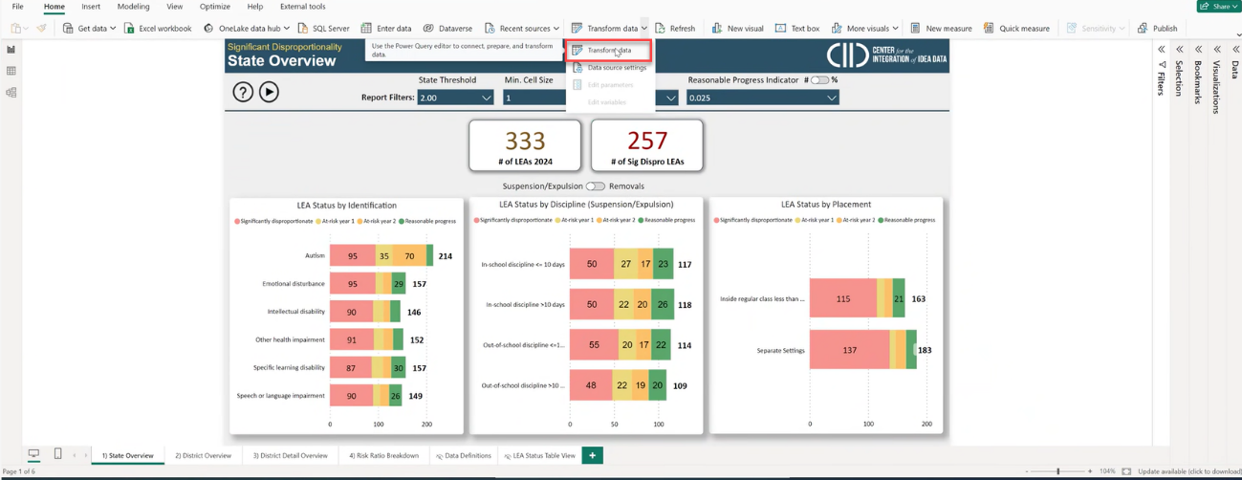

In Power Query, the queries contain a list of tables and report measures essential to the report. Each table needs to be pointed to your CEDS Data Warehouse to ensure that the correct source data is used for the report. This includes each of the queries in the following folders:

* Identification Tables
* Discipline Tables
* Placement Tables
* Reference Table Tables

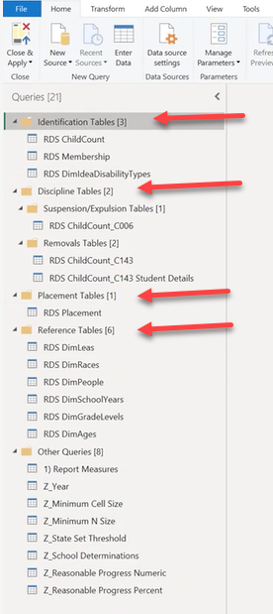

Click on each table, and then select the advanced editor.

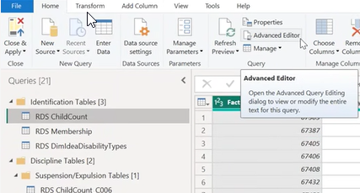

In the advanced editor update the IP Address in one place, and the Database name in three places. This will need to happen in each of the following tables:

* RDS ChildCount
* RDS Membership
* RDS.Placement
* RDS.ChildCount_C006
* RDS ChildCount_C143
* RDS ChildCount_C143 Student Details
* RDS DimLeas
* RDS DimRaces
* RDS DimPeople
* RDS DimSchoolYears
* RDS DimGradeLevels
* RDS DimAges
* Year

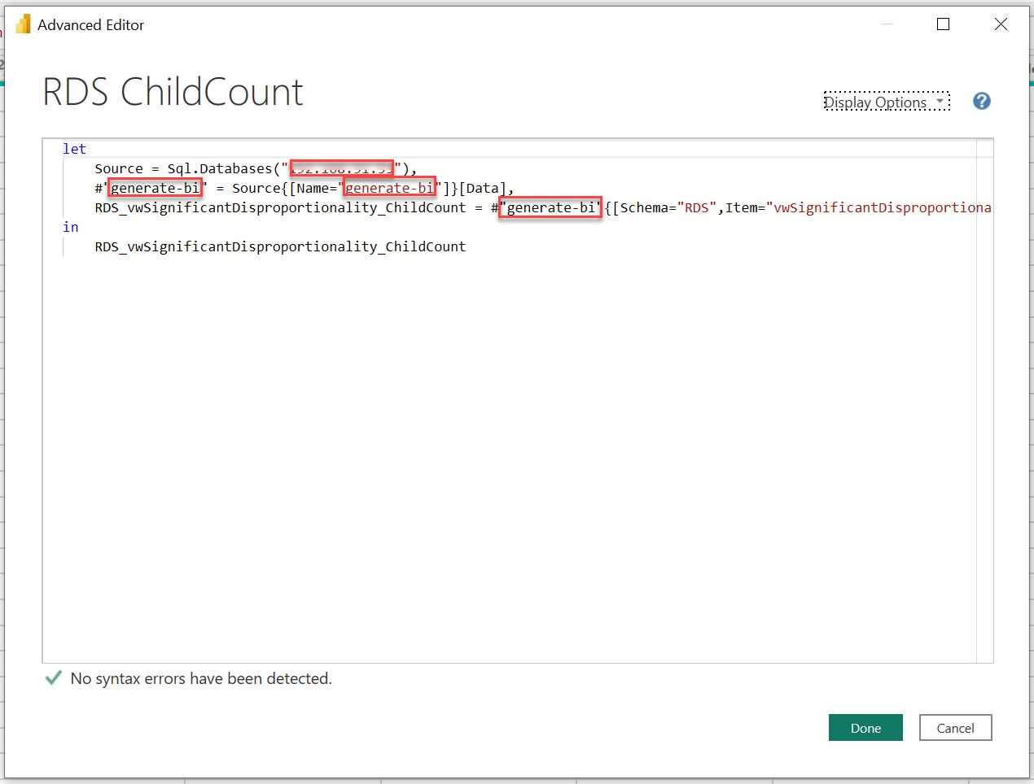

 After each table is updated with the name and IP address of your CEDS Data Warehouse, click close and apply. Your dataset will now refresh and cache within your report. This may take a few minutes, depending on the size of your dataset.

After the dataset is updated, close Power Query. After connecting the dataset, the front end of the report can be reviewed and used.

# Distribution

This report contains Student ID numbers and other PII, so ensuring that it is shared only with authorized individuals is important. Refer to your SEA’s policies and procedures before sharing this report. While the .pbix can be sent to individuals with Power BI Desktop, CIID recommends that this report is distributed with internal state staff through an Online Power BI Workspace. Doing this ensures that access can be limited to appropriate individuals, that the report cannot be edited, and provides multiple sharing options, such as embedding into a Teams Channel.

To share through an online workspace, sign into office.com, and select Power BI on the menu icon. In Power BI, create a new workspace in Power BI by adding the required information.

Once the workspace is created, upload the .pbix file to the workspace.

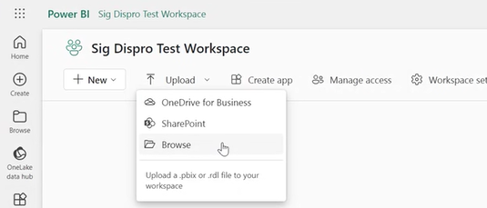

After the report is uploaded in the workspace, the dashboard will be available to use and share by clicking on the .pbix file.

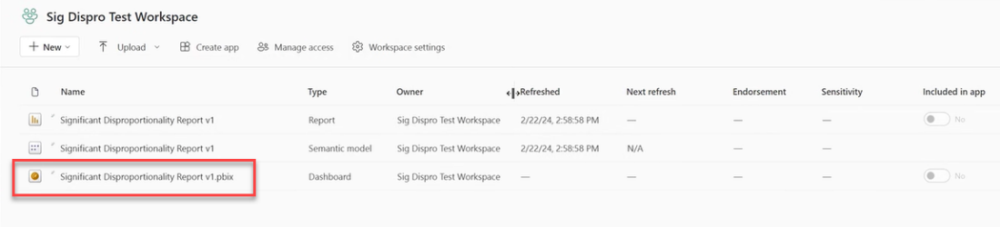

Once you have navigated to the report, manage permissions to access the dashboard with appropriate individuals in your organization, by clicking share.

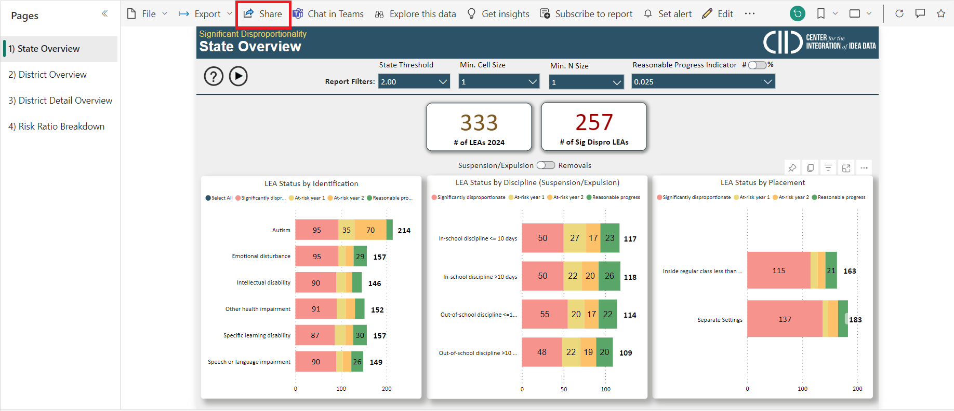

Type in the name of the person you want to share with. Then click the method you would like to send through.

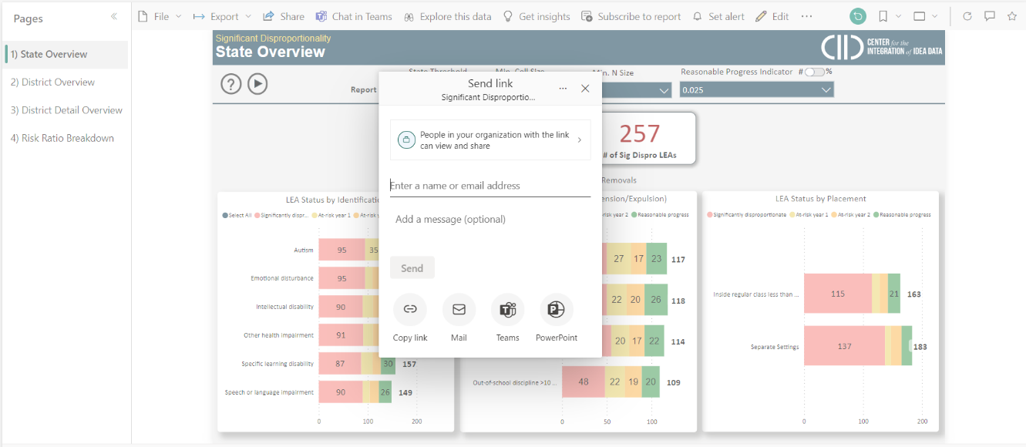

# Refreshing Data

Administrators of the report can refresh the data in different ways:

* If using the report as a desktop .pbix file, then click the refresh button to view updated data.
  + If this report is being used in the workspace, after refreshing data, then click publish to allow authorized users to view the data.
* To refresh from workspace, go to the semantic model and click the refresh button.

